B’s Fab Polaris General Spare Tire / Accessory Rack Installation Instructions

- Bolt the center tire mount bar VERY LOOSLEY to the two sides pieces using four (4) of the nuts and bolts provided. Be sure tire mounting platform is angled towards the back of the rack or you could have it on backwards. See illustration below.

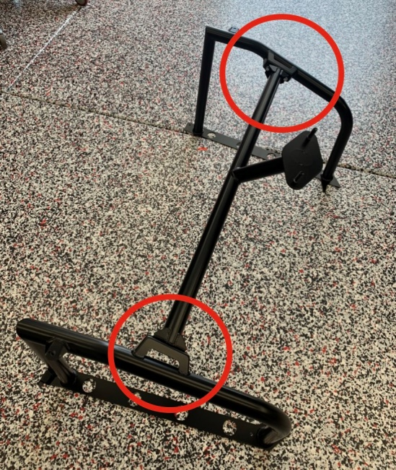

- Set the loosely assembled rack on top of the bed sides.

- Align one side of the bottom metal plate to the top of the plastic bed side and drill the two holes thru the plastic bed side that are pre drilled in the metal plate, see photo below. Only do 1 side at a time!

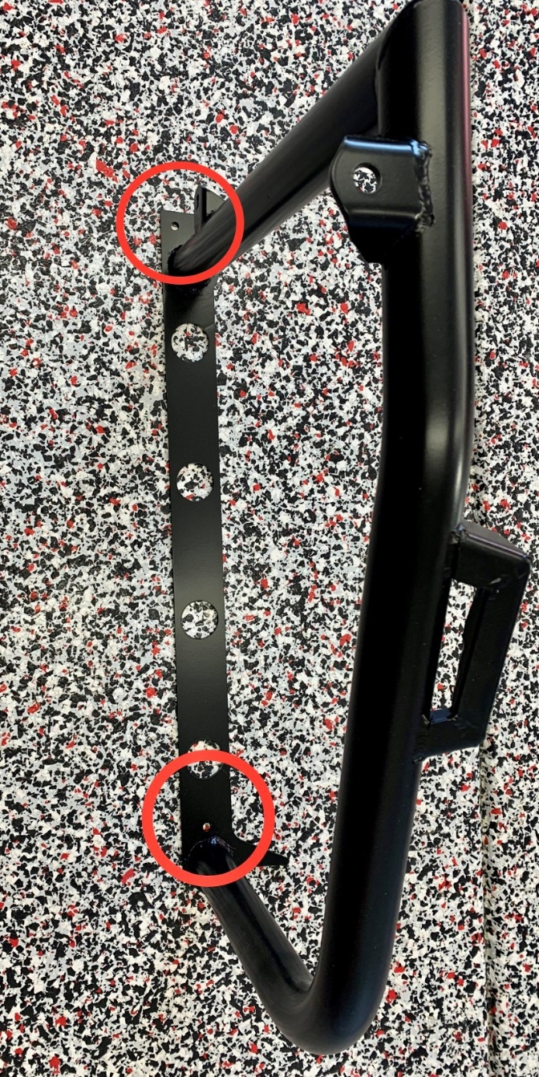

- Install the provided nuts and bolts thru holes you just drilled and then tighten, you will need to remove the bed side to get the nuts on the bolts, double sided taping the nut to the end of your finger will help to get the nut started (see pic on next page) DO NOT OVERTIGHTEN, you don’t want to smash the plastic.

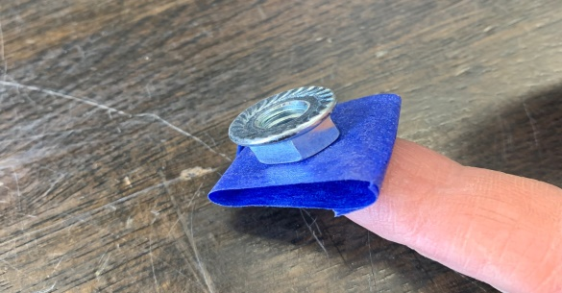
- Repeat steps 3 and 4 for the opposite side.

- Tighten the four (4) bolts that were loosely installed on the center tire mount bar from step 1 and be sure the bed is closed and latched completely before moving onto step #7.

- You will see two tabs welded to the front tubes on your rack, these are there so you can bolt your rack to the factory cage, see pics below. We strongly suggest using these tabs to bolt your new rack to the cage as it will dramatically help with stability so we highly recommend you use them. The brackets that bolts to the factory cage will use the 2 longer bolts that are supplied in your hardware kit.

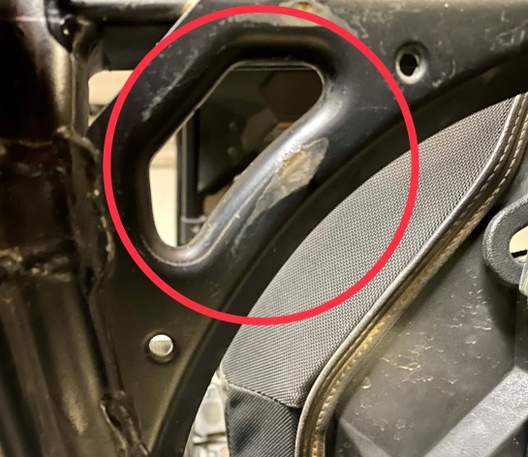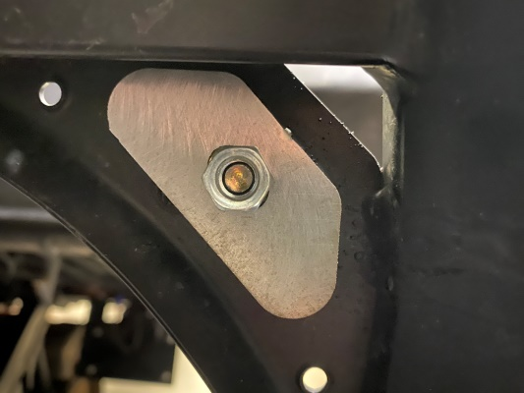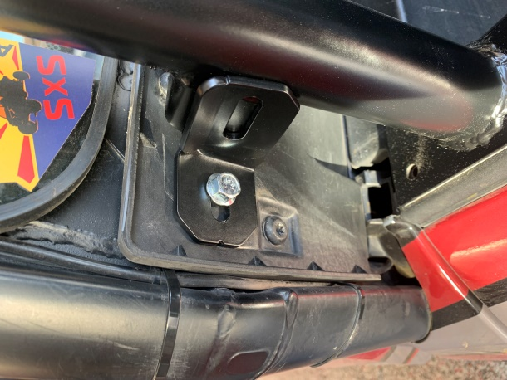

It has come to our attention that some customers who have purchased our spare tire / accessory racks have not been using the bed stabilizer brackets. With this being said it has caused some issues. Please note that these racks were designed and engineered to always use the bed stabilizer brackets when vehicle is in use and failure to do so may result in damage to your rack. Again please be sure you are using the bed stabilizer brackets as to not cause damage to your rack!

*After rack has been installed use caution when tipping bed due to the added weight!

Thank you for your order! We greatly appreciate your business. Your satisfaction is very important to us. If for any reason you are not satisfied, please contact us so that we can resolve any issues that you may have.
We have taken great care to manufacture, pack and ship your order as quickly and professionally as possible. When you are happy with your order, please let others know by leaving us a 5 star rating on our website, positive feedback on eBay, commenting on our Facebook page or posting on the Polaris General forum and Facebook groups. This lets us know that you, our valued customers are happy with our product and services and this also helps others in making the right decisions on whom to buy from.

Web – www.bsfabutv.com
Email – info@bsfabutv.com
Phone – 602-577-0460

