Instructions For B’s FAB Upper iPad Mount

- Install the Axia Alloys clamp around factory cage tube in the approximate area you want the mount to be positioned and then slide the Axia Alloys universal mount into the clamp and install bolt & nut provided. Look for the recess on one side of the clamp that the nut goes into. See pics below for reference.

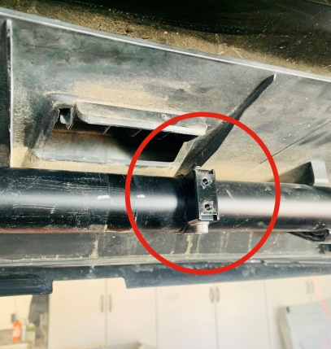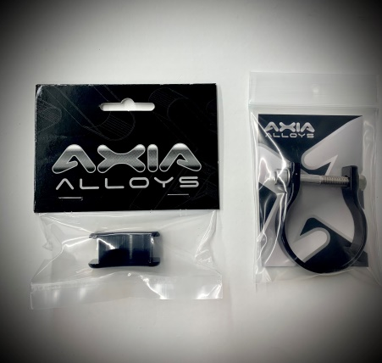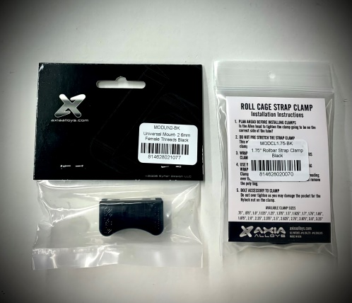
- Attach the L shaped bracket to the Axia Alloys mount with two allen head screws and lock washers provided, the long leg of the bracket is the top, see pic below for reference.

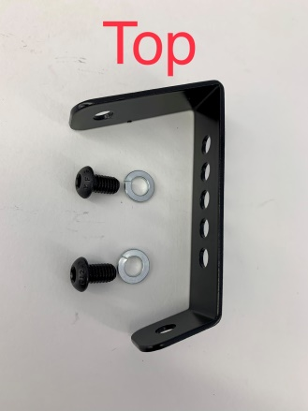

- Attach the mounting plate to the L shaped bracket with two flange head bolts, washers & nylock nuts provided, see pic below.

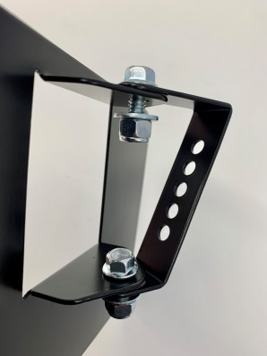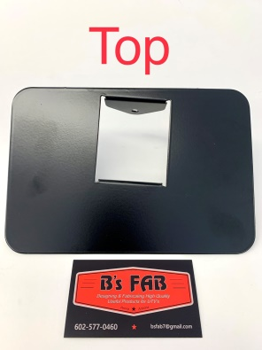

- Adjust the mount horizontally and vertically where you want it and tighten all hardware.

- Once you have test fit your tablet onto the mounting plate and you are happy with the position of the plate you can now install the 4 pieces of self-adhesive Velcro strips near each corner of the mounting plate, see pic below. Test fit your tablet one more time so you are sure you know where you want it and then pull the backing off the Velcro and then carefully push your tablet on to the mounting plate and push firmly. We suggest you do not try and remove the tablet for 24 hours so the adhesive on the Velcro has time to completely adhere to the mounting plate and the tablet.

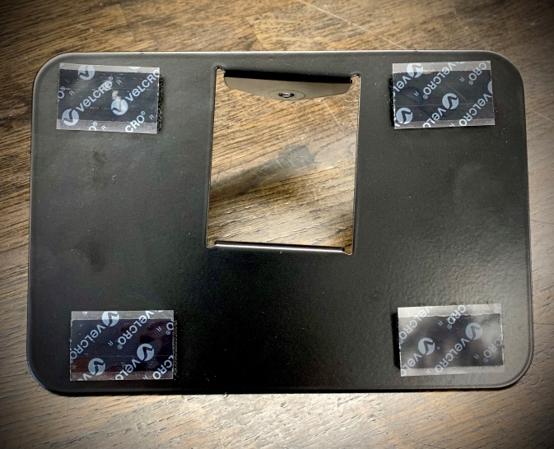

B’s Fab would like to thank you for your order! We greatly appreciate your business. Your satisfaction is very important to us. If for any reason you are not satisfied, please contact us so that we can resolve any issues that you may have.

We have taken great care to design, manufacture, pack and ship your order as quickly and professionally as possible. When you are happy with your order, please let others know by leaving us positive feedback on eBay, commenting on our Facebook page or posting on the forums and in Facebook groups. This lets us know that you, our valued customers, are happy with our product and services and this also helps others in making the right decisions on whom to order from.

We always welcome your suggestions on how to improve our products and or services.

Again we thank you for your order!

Email – info@bsfabutv.com
Web – www.bsfabutv.com
Facebook – B’s FAB LLC

B’s FAB
20403 N Lake Pleasant Rd.
Suite #117-485
Peoria, Arizona 85382
Phone – 602-577-0460

