INSTALLATION INSTRUCTIONS

- Place the mount where you want it on the plastic tab under the bed on drivers’ side, drill two ¼” holes using the plate mount as a guide. Before you drill the holes be sure and tilt the bed and make sure it’s not going to hit muffler or tire. and attach using two of the supplied nuts & bolts, see picture below.

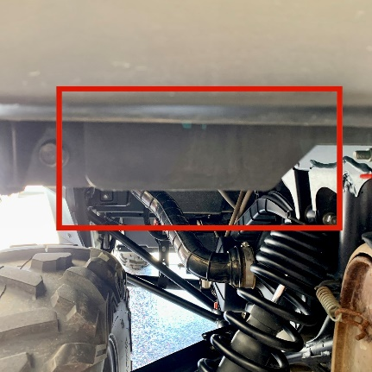

- Carefully route the wiring over to the factory connector mounted on top of the frame, see picture below. Now unplug the factory connector and plug the new license plate wiring into that connector then plug other side of factory connector into that plug. Be sure all wiring is tied up well and doesn’t get pinched when the bed closes. Plug the wiring harness connectors into the pigtail connectors on the backside of the LED light, be sure to plug red wire to red wire.

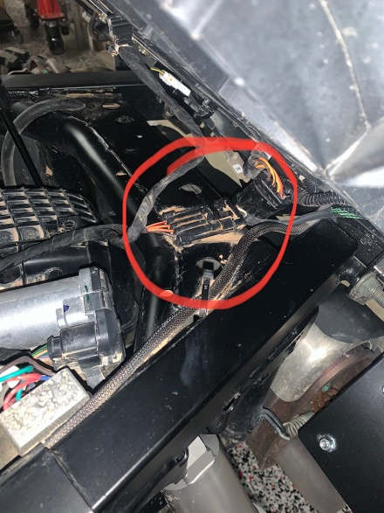

B’s Fab would like to thank you for your order! We greatly appreciate your business. Your satisfaction is very important to us. If for any reason you are not satisfied, please contact us so that we can resolve any issues that you may have.

We have taken great care to design, manufacture, pack and ship your order as quickly and professionally as possible. When you are happy with your order, please let others know by leaving us positive feedback on eBay, commenting on our Facebook page or posting on the forums and in Facebook groups. This lets us know that you, our valued customers are happy with our product and services and this also helps others in making the right decisions on whom to order from.

We always welcome your suggestions on how to improve our products and or services.

Again we thank you for your order!

Web – www.bsfabutv.com
Email – info@bsfabutv.com
Phone – 602-577-0460
Facebook – https://www.facebook.com/tigweldinginphoenix/?modal=admin_todo_tour

B’s Fab
20403 N Lake Pleasant Rd.
Suite #117-485
Peoria, Arizona 85382

