Instructions for Rechargeable Dome Light Kit

This kit was designed for all Polaris UTV’s that have oval shaped mounting sockets cast in the factory roof.

- Install mounting base on the raised oval socket, using the 2 screws provided. Important not to overtighten them its just plastic.
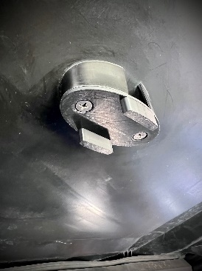
- Remove the plastic film from metal strip being careful not to get surface dirty set aside. Remove the film from one side of the double sided tape. Carefully holding the metal strip with the clean surface up apply double sided tape. Press the 2 pieces together firmly, now carefully remove last piece of film the double sided tape keeping it clean and set aside. Make sure mounting surface on new mount is clean. You’re now ready to install the metal strip on the new Dome light mount. Centered is best but don’t worry the powerful magnet doesn’t care much.
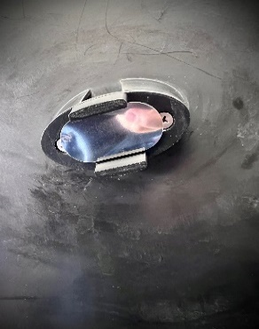

- Last clean back of LED Light set aside, then remove the film from the magnet. Without getting the surfaces dirty apply the magnet to the back of the light. Do your best to keep magnet centered and aligned with light.

- Using the provided USB cord, charge your new light for approx 1 hour to get it full charge. Location of charging port is illustrated below.

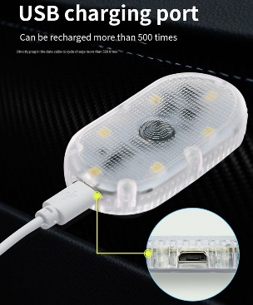

- Once light has a full charge simply attach to new mount with magnet facing up. Your ready to enjoy the ride knowing you got light when needed.

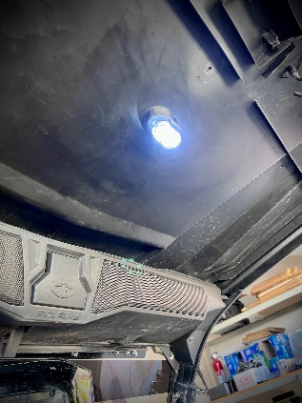

B’s Fab would like to thank you! It’s very important to us, that you know we do appreciate your support for our small business. If not satisfied please reach out and let know what your issues might be.

Customer service is a very top priority for B’s Fab, we’ve done our best to provide all aspects of this. From product support the ordering process, manufacturing to the shipping process. We would appreciate a moment of your time to share your expereinces with others from your favorite social media source or ecommerce site you purchased from.

We welcome all suggestions on how to improve either our products and or services provided to this great community.

Again thank you!

Web – www.bsfabutv.com
Email – info@bsfabutv.com
Phone – 1-888-779-1497

Facebook – https://www.facebook.com/tigweldinginphoenix/?modal=admin_todo_tour
Instagram - https://instagram.com/bsfabutv
YouTube - https://www.youtube.com/@Bsfabutv/playlists

B’s Fab
20403 N Lake Pleasant Rd.
Suite #117-485
Peoria, Arizona 85382

