Polaris General Spare Tire / Accessory Rack Installation Instructions

- Bolt the cross bar tire mount bar VERY LOOSLEY to the two sides pieces using eight (8) of the 5/16” nuts and bolts provided. Be sure tire mounting platform is angled towards the back of the rack or you could have it on backwards. See pic below.

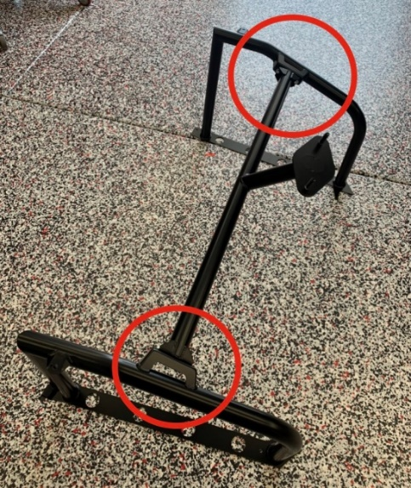

- Set the loosely assembled rack on top of the bed sides.

- Align one side of the bottom metal plate to the top of the plastic bed side and drill the hole through the plastic bed side that is pre drilled in the metal plate, see photo below. Only do 1 side at a time!

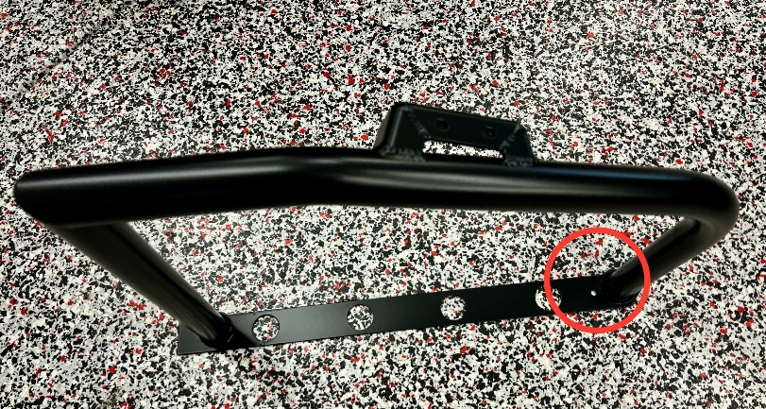

- Install the provided nuts and bolts thru holes you just drilled and then tighten, you will need to remove the bed side to get the nuts on the bolts, double sided taping the nut to the end of your finger will help to get the nut started see pic below. DO NOT OVERTIGHTEN, you don’t want to smash the plastic.

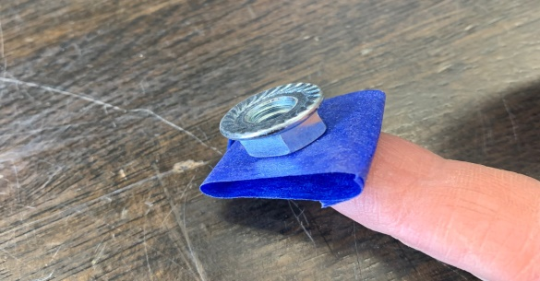
- Repeat steps 3 and 4 for the opposite side.

- Tighten the eight (8) bolts that were loosely installed on the center tire mount bar from step 1 and be sure the bed is closed and latched completely before moving onto step #7.

- Next you will drop the two (2) lock and ride hole spacers down into the 2 most outer lock and ride holes, see pics below.

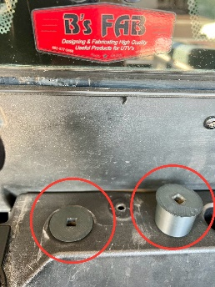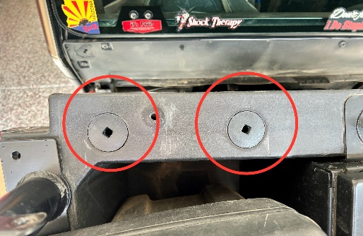

- You will see two (2) tabs welded to both front tubes on your rack, these are there so you can bolt your rack to the stabilizer brackets. The stabilizer brackets go to the front side of the tabs, see pics below. Use two (2) of the carriage bolts and nuts to bolt the stabilizer brackets to the rack and leave them loose for now, carriage bolt head goes toward front of car and nut goes towards back of car. Now do the same on the opposite side. Next you will run the 5” long carriage bolts through the stabilizer brackets, down through the lock and ride hole spacers and out the bottom of the lock and ride holes, be sure the recessed are in the lock and ride hole spacers aligns with the carriage bolts shoulder and finally install the supplied cup washer as shown in the pic below along with the nut and tighten everything up, DO NOT OVERTIGHTEN or you could break the plastic!

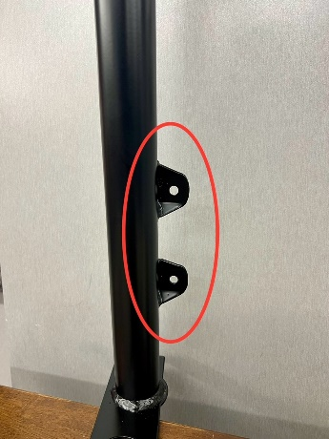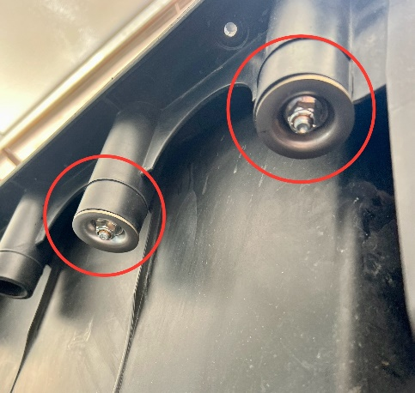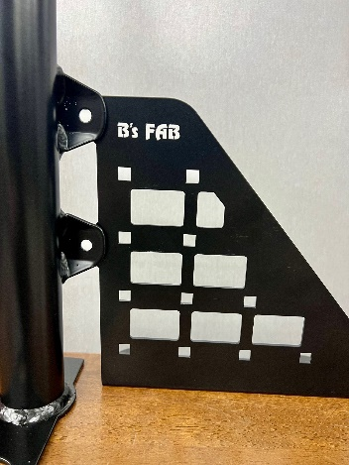

*After rack has been installed use caution when tipping bed due to the added weight!

Thank you for your order! We greatly appreciate your business. Your satisfaction is very important to us. If for any reason you are not satisfied, please contact us so that we can resolve any issues that you may have.
We have taken great care to manufacture, pack and ship your order as quickly and professionally as possible. When you are happy with your order, please let others know by leaving us a 5 star rating on our website, positive feedback on eBay, commenting on our Facebook page or posting on the Polaris General forum and Facebook groups. This lets us know that you, our valued customers are happy with our product and services and this also helps others in making the right decisions on whom to buy from.

Web – www.bsfabutv.com
Email – info@bsfabutv.com
Phone – 602-577-0460

