B’s FAB Polaris Xpedition Driving Light Kit Instructions

KIT INCLUDES
- 2 - LED lights
- 1 - Mounting bracket
- 2 - Speed nuts
- 2 -Bolts
- 1 - Y-harness
- 1 – (Optional) OEM switch

- Remove grill and hood
- Remove bumper, there are 2 lower bolts and 4 upper bolts
- Remove the front fascia, 4 push pins and 2 bolts
- Remove both light hole covers from backside of front fascia
- Install speed nuts onto the lower front fascia as shown below
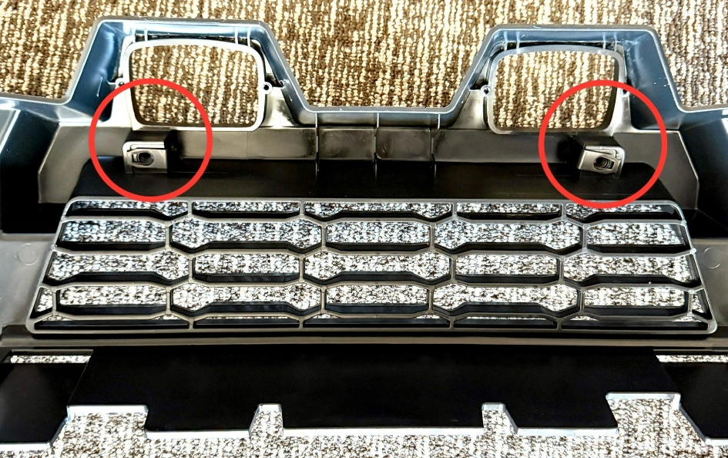

- Install driving lights onto bracket and bolt bracket into fascia as shown below
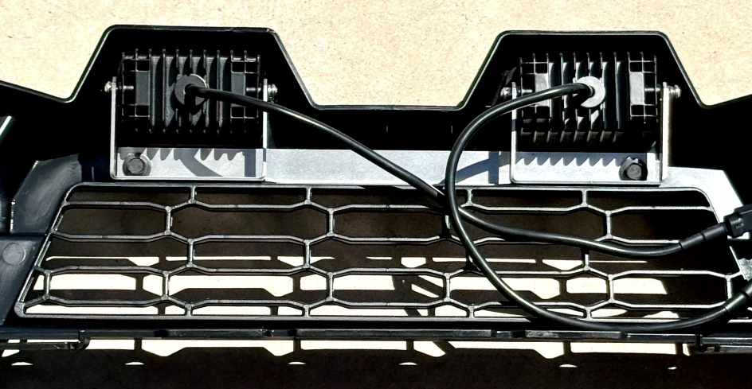

- Install & route wiring into backside of fascia as shown below and zip tie into place, leave the end of the Y harness loose on drivers’ side
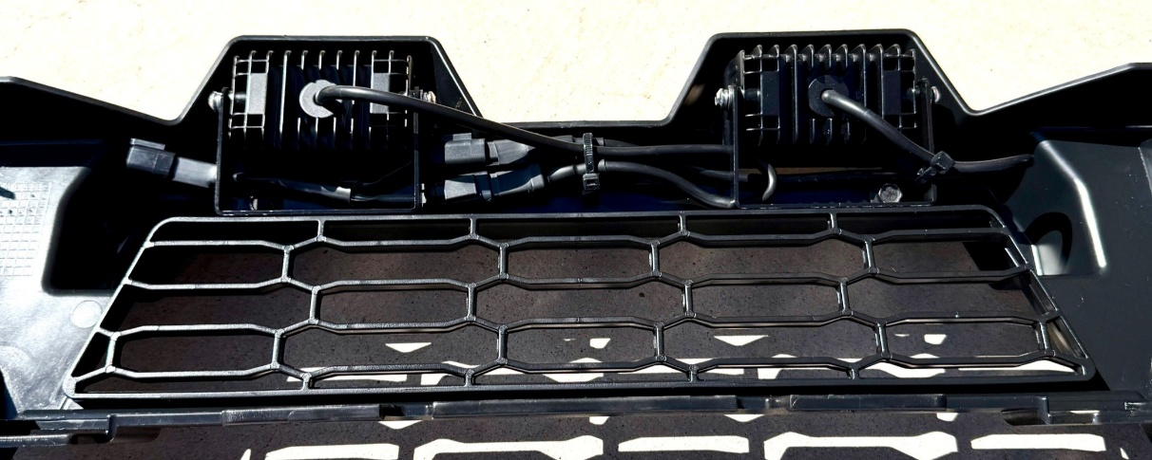

- Locate existing plug near bottom of radiator as shown in pic below, remove dust cap from existing plug and plug into Y connector and reinstall fascia back onto machine
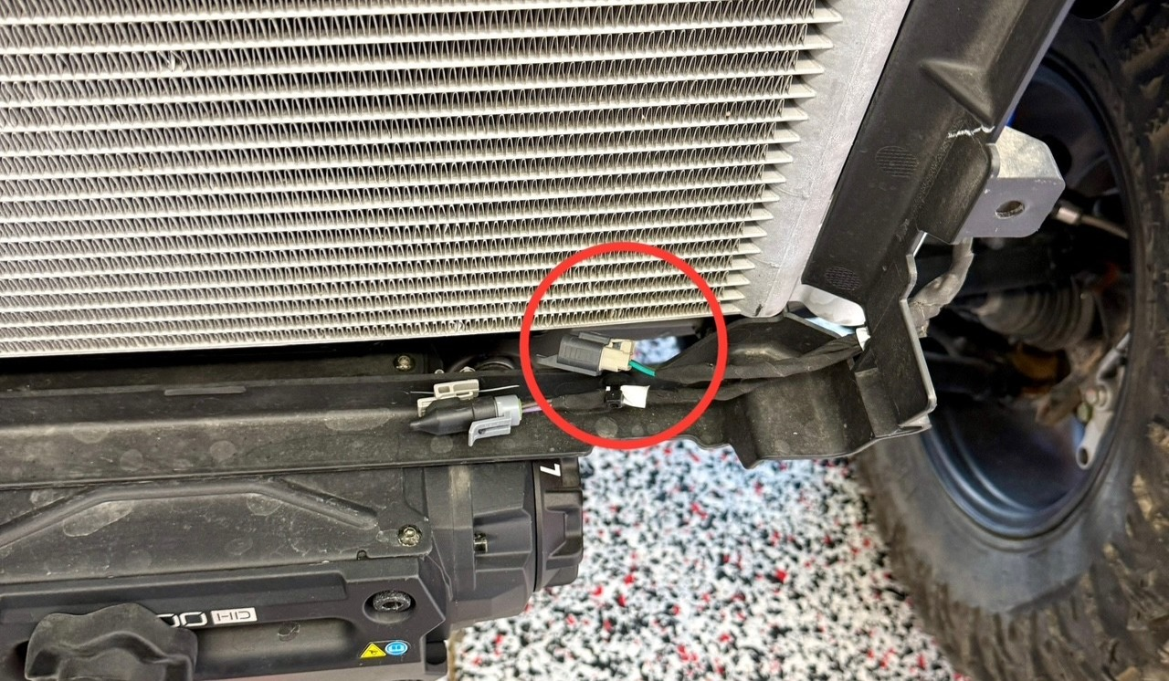

- Switch installation - if optional switch was purchased. Remove switch cover plate next to factory headlight switch. Locate red switch plug by looking through switch hole and plug switch into the plug. Push switch into opening, you will hear it click into place
- Aim lights as desired.

Thank You!
We really appreciate your business, and your satisfaction is very important to us. If you are not satisfied, we ask you please contact us so can resolve any issues or concerns you may have.
Web – www.bsfabutv.com
Email – info@bsfabutv.com
Phone – 1-888-779-1497

